## Maven - Training



Mithun Reddy Lacchannagari (mithunreddytechnologies@gmail.com)

## - Agenda



* Introduction
* Installation
* Content – pom.xml
* Examples



- Introduction

|  |  |
| --- | --- |
| **Type** | Java Based Build Tool |
| **Vendor** | Apache |
| **Is Open Source?** | Yes |
| **Version** | 3.5.2 |
| **Operating system** | Cross Platform |
| **Software Download URL** | https://maven.apache.org/download.cgi |
| **Is executable software?** | No, download as zip, extract and use it. |
| **Reference Websites** | 1) https://[www.petrikainulainen.net/programming/gradle/getting-started-with-gradle-dependency-](http://www.petrikainulainen.net/programming/gradle/getting-started-with-gradle-dependency-)  management/ |



- Introduction

Apache Maven is a software project management and comprehension tool. Based on the concept of a project object model (POM), Maven can manage a project's build, reporting and documentation.

The most powerful feature is able to download the project dependency libraries automatically from maven central repo, maven remote repo or local repo.



- Contents in pom.xml

<project xmlns=[*"h*](http://maven.apache.org/POM/4.0.0)*t*[*tp://maven.apache.org/POM/4.0.0*](http://maven.apache.org/POM/4.0.0)*" xmlns:xsi=*[*"h*](http://www.w3.org/2001/XMLSchema-instance)*t*[*tp://www.w3.org/2001/XMLSchema-instance*](http://www.w3.org/2001/XMLSchema-instance)*"*

xsi:schemaLocation=[*"h*](http://maven.apache.org/POM/4.0.0)*t*[*tp://maven.apache.org/POM/4.0.0*](http://maven.apache.org/POM/4.0.0) [*http://maven.apache.org/xsd/maven-4.0.0.xsd"*](http://maven.apache.org/xsd/maven-4.0.0.xsd)*>*

<modelVersion>4.0.0</modelVersion>

<groupId>com.bt</groupId>

<artifactId>maven-java-project</artifactId>

<version>0.0.1-SNAPSHOT</version>

<packaging>jar</packaging>

<name>maven-java-project</name>

<url[>h](http://maven.apache.org/)t[tp://maven.apache.org](http://maven.apache.org/)</url>

<properties>

<project.build.sourceEncoding>UTF-8</project.build.sourceEncoding>

</properties>

<dependencies>

<dependency>

<groupId>junit</groupId>

<artifactId>junit</artifactId>

<version>3.8.1</version>

<scope>test</scope>

</dependency>

</dependencies>

</project>



- Contents in pom.xml

All POM files require the **project** element and three mandatory fields: **groupId, artifactId,version.**

Root element of POM.xml is **project** and it has three major sub-nodes .

**groupId :** This is an Id of project's group. This is generally unique amongst an organization or a project. For example, a banking group com.company.bank has all bank related projects.

**artifactId** : This is an Id of the project.This is generally name of the project. For example, consumer-banking. Along with the groupId, the artifactId defines the artifact's location within the repository.

**version:** This is the version of the project.Along with the groupId, It is used within an artifact's repository to separate versions from each other. For example: com.company.bank:consumer-banking:1.0com.company.bank:consumer-banking:1.1.



- Maven Repositories

A Maven repository can be one of the following types:

* Local Repository
* Central Repository
* Remote Repository

### Local Repository



- Maven Repositories

The maven local repository is a local folder that is used to store all your project’s dependencies (plugin jars and other files which are downloaded by Maven). In simple, when you build a Maven project, all dependency files will be stored in your Maven local repository.

By default, Maven local repository is default to .m2 folder:

1. Unix/Mac OS X – ~/.m2 (/Users/BhaskarReddy/.m2/repository)
2. Windows – C:\Users\{your-username}\.m2

Update Maven Local Repository



- Maven Repositories

Normally, We will change the default local repository folder from default .m2 to another more meaningful name as follows.

Find {M2_HOME}\conf\settings.xml, update localRepository to something else.

<!-- localRepository

| The path to the local repository maven will use to store artifacts.

|

| Default: ${user.home}/.m2/repository

<localRepository>/path/to/local/repo</localRepository>

-->

<localRepository>D:/maven_repo</localRepository>



- Maven Repositories

### Maven Central Repository

The central repository is the repository provided by the Maven community. It contains a large repository of commonly used libraries. This repository comes into play when Maven does not find libraries in the local repository.

The central repository can be found at: [http://search.maven.org/#browse.](http://search.maven.org/#browse)



- Maven Repositories

### Remote Repository

Enterprises usually maintain their own repositories for the libraries that are being used for the project. These differ from the local repository; a repository is maintained on a separate server, different from the developer's machine and is accessible within the organization.

## - Maven Architecture

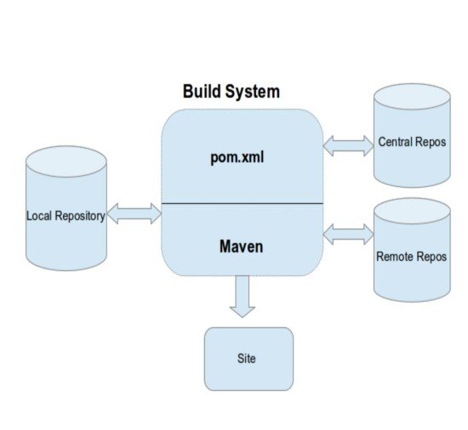

- Maven Goals

To invoke a maven build you set a life cycle goal.

mvn install : Invokes generate*, compile, test, package, integration-test, install.

mvn clean: Invokes just clean.

mvn clean compile : Clean old builds and execute generate*, compile. mvn compile install : Invokes generate*, compile, test, integration-test, package, install.

mvn test clean : Invokes generate*, compile, test then clean.



- Maven Environment Setup

M2_HOME JAVA_HOME

mvn archetype:generate

# Questions ?

Thank you

